Chapter 2
2.1.1 Why the DOM zone is an ideal study object
Why do we select PJM-DOM as the focal region for this study? Because PJM is the largest regional transmission organization in the United States, responsible for coordinating wholesale power markets and grid operations across 13 states.
Within PJM, DOM is a settlement zone whose corresponding service territory is the Virginia Electric and Power Company, and this utility serves most load nodes in Virginia.
Furthermore, Northern Virginia’s data-center cluster is regarded as one of the largest in the world; this area hosts more than 150 data centers, and the aggregate in-service load already exceeds 5,050 MW, hence its electricity price data are highly relevant to our research.
In PJM’s power market, these large loads face two key influencing parameters: (1) hourly locational marginal prices (LMPs) at the zonal level, which in both the day-ahead and real-time markets reflect weather, fuel, and network constraints; and (2) peak-contribution mechanisms that shape annual cost exposure and incentivize users to reduce coincident peak demand on summer weekdays in the afternoon.
Our empirical design examines both mechanisms simultaneously: the LMP series captures the weather–price link, whereas the peak-cost incentive is identified through timing indicators that interact with weather variables and lagged prices.
2.1.2 Data map for DOM (2018–2025)
We downloaded PJM-DOM’s marginal prices and electricity consumption from PJM Data Miner 2; before analyzing these datasets, we first standardize all series to UTC hourly timestamps.
In doing so, we primarily employ the following four classes of inputs:
1. Metered load
This dataset reports realized electricity load in the PJM-DOM zone, typically measured in MW; it reflects the true demand of all users within DOM (primarily industrial customers and data centers) and is the quantity the system must serve.
Only with this dataset can we ascertain and demonstrate whether “data centers, as large loads, avoid or respond during peak windows,” and only after understanding and analyzing actual load can we detect users’ other proactive behaviors beyond weather and price effects—for example, data-center customers adjusting their peak-shifting strategy for this year based on the NSPL values to allocate costs.
In the first load statistics table, we parse datetime_utc into pandas datetimes aligned to the top of the hour, and we cast load_mw to float; next, we de-duplicate to hourly granularity using mean aggregation, provide an optional linearly-interpolated load_mw_filled column for short gaps (< 2 hours), and flag other anomalous records.
Finally, we must verify non-negativity for all values, spatial consistency for the zone, and unit integrity.
2. Day-ahead LMP
The day-ahead marginal price is the locational wholesale price that utilities determine one day in advance—based on historical data, available generation, end-use demand, and other factors—representing the best forecast and financial commitment for “tomorrow’s” supply–demand conditions.
By contrasting realized prices with expected prices, we can identify how specific times and specific events affect electricity prices; meanwhile, data-center procurement and hedging strategies also rely on day-ahead LMPs to make decisions—e.g., whether to “lock in the day-ahead price” or “wait for real-time,” and the degree of day-ahead participation to determine the share of energy sourced at day-ahead prices.
3. Real-time LMP
The real-time marginal price is the settlement price to deliver 1 MWh to a node at the current operating moment.PJM computes prices on a rolling basis under Security-Constrained Economic Dispatch (SCED) every five minutes, while settlements are often hourly averages.
It reflects real-world scarcity signals in supply capability and demand; therefore, comparing day-ahead with real-time prices allows us to see the actual price movements during events such as Winter Storm Elliott and extreme summer heat.Accordingly, data centers and other customers can identify peaks and diagnose congestion intervals, then activate alternative power solutions.
4. Weather composites
To study how exogenous climate conditions drove regional wholesale prices during 2018–2025, we collected hourly observations from multiple NOAA/ISD weather stations and conducted the necessary statistical processing.
The primary purpose of this dataset is to provide exogenous explanatory variables and a basis for identifying and delineating event windows, as well as to supply quantifiable meteorological parameters for the subsequent engineering-economic assessment.

Dataset | Key fields (sample) | Unit | Time basis | Notes
Metered load | timestamp_utc, load_mw | MW | Hourly (UTC; EPT if provided) | PJM DOM hourly metered load; UTC/EPT timestamps present
Day-ahead LMP | datetime_beginning_utc, zone, lmp, congestion, marginal_loss, pnode_name | $/MWh | Hourly (day-ahead) | Day-ahead LMP with congestion and marginal loss components where available.
Real-time LMP | datetime_beginning_utc, zone, pnode_name, rt_lmp, rt_congestion, rt_marginal_loss | $/MWh | Hourly (real-time) | Real-time LMP (hourly-averaged); components available if present.
Weather composites | temp_c, dewpoint_c, rh_pct, wind_chill_c, wind_speed_ms, cdd, hdd, n_stations | Mixed (℃/℉, %, m/s, hPa) | Hourly (America/New_York; UTC mirror if provided) | Composite/derived weather features aligned to DOM; ready for modeling.
Weather hours per station | station, rows | Counts / hours | Hour counts by station | QA table: per-station hourly coverage summary.
Weather span per station | station, min, max | Timestamps / dates | Coverage span by station | QA table: per-station min/max timestamp and span.
Table2.1 PJM DOM data inventory (2018–2025)
2.13 Quality Control and Missingness Policy
We anchor the timeline to UTC standard time and align metered load, day-ahead prices, real-time prices, and weather data to the same hourly axis, so that we avoid the local-time distortions caused by daylight saving time—namely, the “missing hour” in March and the “extra hour” in November.
If local time were used for computation, duplicated and missing timestamps would inevitably occur, which would in turn cause problems in subsequent merging and modeling.
After harmonizing all series to a common timestamp, we can perform systematic data cleaning as follows:
1. Coverage ledger
Because real-world datasets are inevitably incomplete, directly analyzing data with gaps would induce large biases and may even misalign time series, thereby derailing downstream analysis.
The coverage ledger is therefore used to record—and substantiate—the time coverage and gaps for the four PJM-DOM datasets, thus providing an audit trail for later merging and a basis for assessing data health.
Concretely, we deduplicate on the UTC master timeline and standardize formats, merge at an hourly frequency, and classify gaps into “long” and “short”; we flag long gaps with is_gap, while short gaps are supplemented via linear interpolation.
Using the above procedures, we compute monthly and hourly coverage diagnostics for each PJM-DOM dataset.
The statistics indicate that, during 2018–2025, the DA/RT price series and total load cover nearly all hours, with only sporadic short gaps around holidays and DST transitions, accounting for less than 1% of all observations.
Weather coverage is approximately 95%–98%, with missingness concentrated in a few station outages and extreme-weather intervals, where nighttime and winter gaps are relatively more frequent.
2. No price imputation
To avoid distorting conclusions about event studies, congestion costs, and loss factors through price interpolation, we preserve the authenticity and testability of price signals.
In processing RT and DA price statistics, when we detect missing values we only tag them with is_gap_da / is_gap_rt and document them in the coverage ledger.
For load, if isolated short gaps of less than two hours appear, we may fit a seasonal state-space model with Kalman smoothing; here we adopt a weekly seasonality of 168 hours (7 days × 24 hours) and focus on the baseline load level at the current timestamp to produce load_mw_filled at the gap position.
Simultaneously, we generate an is_imputed_load indicator to identify imputed rows and an “imputation share” metric to summarize the proportion of supplemented values, which facilitates reliability assessment; importantly, the original values are retained and not overwritten.
3. Weather QC
To endow the model inputs with temporally coherent weather features that both respect physical plausibility and do not bias results due to gap-filling, we apply the following cleaning protocol.
First, for each station and each hour, we check physical reasonableness and directly drop clearly impossible readings—e.g., temperatures outside feasible climatic bounds, relative humidity (RH) below 0 or above 100, negative wind speeds, or surface pressure below 800 hPa or above 1100 hPa—while tagging these deletions as qc_drop_phys.
If a station exhibits short gaps not exceeding two consecutive hours, we fill only at the missing indices using linear or spline interpolation and set is_interp_short=1, while preserving the original observations in full.
If a gap exceeds two hours or the station is down, we refrain from within-station or cross-station extrapolation; instead, we switch to a cross-station composite: for the given hour, we compute a regional representative value (median or weighted median) across all available stations to fill the gap, recording from_cross_station=1 and the number of contributing stations (n_stations).
Statistically, the share of short-gap interpolation is low and mostly due to momentary dropouts at individual stations; longer gaps largely arise from station outages or extreme-weather impacts.
After cross-station compositing, the regional coverage for temperature, dew point, RH, and wind speed reaches about 95% to 98%.
In addition, we publish in the ledger each station’s minima, maxima, coverage profile, and longest gap length to satisfy data-quality and reproducibility requirements.
4. Outliers are informative
We must not simply remove outliers during cleaning, because anomalous price observations can be valid signals of scarcity and binding constraints, and thus they are valuable for event studies and policy analysis.
Accordingly, in our cleaning protocol, we do not delete, winsorize, or smooth day-ahead (DA) and real-time (RT) prices; instead, we only tag negative and spike prices—for example, is_negative_lmp for negative prices and is_spike_p99_9 for extreme spikes—and we add spike_source to indicate whether a spike originates from energy cost, congestion, or losses.
To identify extreme intervals, we apply rules such as IQR×3, |z| > 5, or the within-year p99.9 threshold; we then retain these tagged prices alongside load and meteorological variables in the panel dataset.When producing figures and descriptive statistics, we summarize the distribution of these outliers separately; only in robustness checks do we include truncated or winsorized comparisons.
At the modeling stage, within SARIMAX or regression frameworks, we address the “heavy-tailed” nature of prices via distributional transforms (e.g., Yeo–Johnson, or component-wise transforms such as log(1 + max(y − q1, 0)) applied separately to energy, congestion, and other components).We also employ robust standard errors, quantile regression, or GLM specifications as alternatives; in event studies, we report both the “full-sample” and the “spike-excluded” results to facilitate comparison.
Finally, our statistics show that, in the DOM sample for 2018–2025, the combined share of negative-price hours and p99.9-exceeding spike hours is roughly 1%, with these extremes clustering more clearly during winter storms and high-load summer periods.
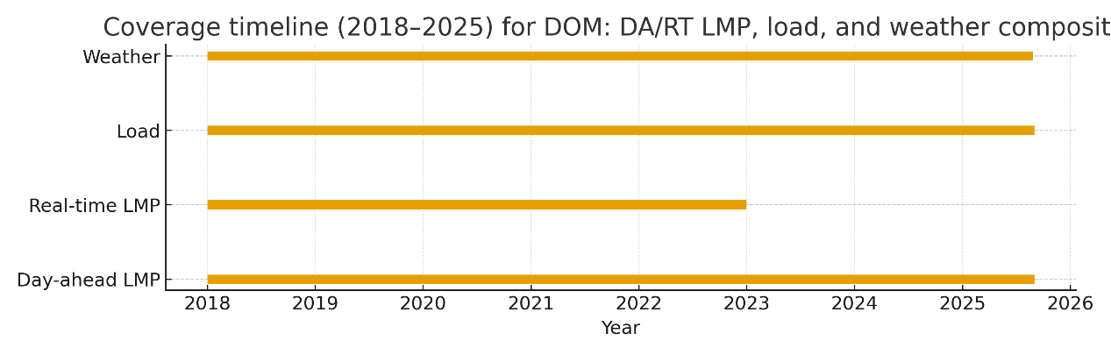
By preserving these outliers, the tail behavior of the real-time versus day-ahead price spread more transparently reveals the impact mechanism of grid congestion and insufficient reserve capacity.
Figure 2.2: Coverage timeline (2018–2025) for DOM: DA/RT LMP, load, and weather composites.
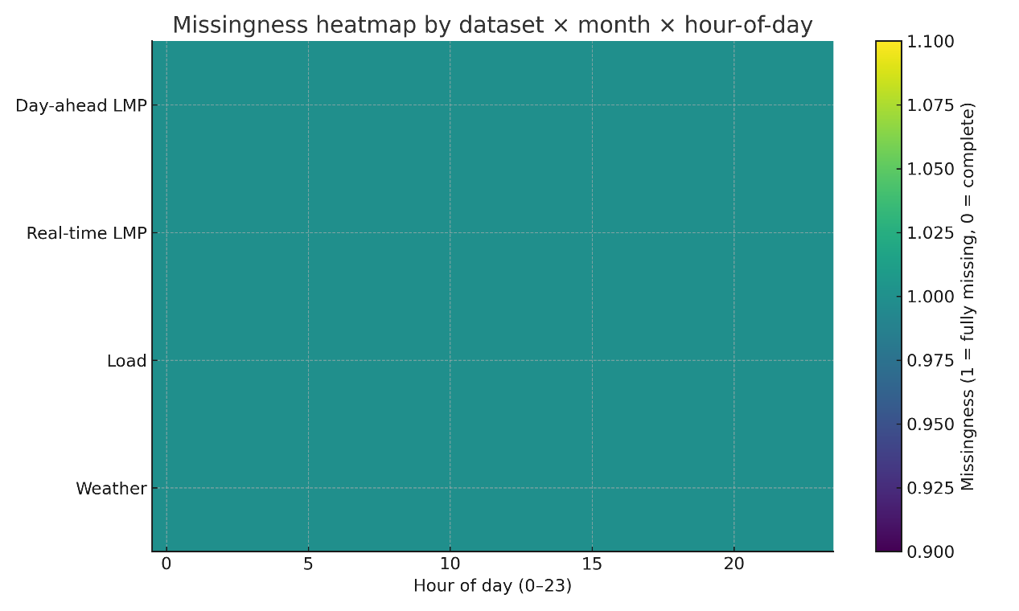
Figure 2.3: Missingness heatmap by dataset × month × hour-of-day
2.14 From raw to model-ready: features tied to identification
To precisely identify price formation and load response, this section conducts a sequence of feature-engineering steps on the raw data—seasonality treatment, distributional transformations, meteorological feature selection, peak-signal construction, and event tagging—so as to generate structured inputs that both preserve economic meaning and fit statistical models, thereby laying the groundwork for subsequent empirical analysis.
1. Seasonality and stationarity treatment
We apply seasonal differencing of order 24 and order 168 to the load, price, and other time series, in order to remove the inherent patterns of “higher loads at the same hour each day” and “weekday price swings recurring on the same day each week.”
During diagnostics, we focus on whether the differenced series are free of unit roots (the central criterion for stationarity) and whether residuals exhibit no significant autocorrelation (to ensure randomness of the series).
2. Distribution-stabilizing transformations
For RT LMP and related price components (energy, congestion, and losses), we first map the original distribution to an approximately normal one via a rank-based transform while retaining the inverse-transform function to preserve interpretability.
In the course of transformation, we explicitly distinguish “stress periods” from regular periods to ensure that extreme-value information remains detectable by the model after transformation.
3. Meteorological feature selection
Using the hourly time window as the unit of analysis, we compute information criteria (e.g., AIC, BIC) between each weather indicator and load/price, and we prioritize indicators that yield significant information gains.
Concurrently, based on the physical logic of “temperature—price,” we emphasize the weight of features closely linked to cooling demand—such as heat index and dew-point temperature—ultimately forming a compact, physically interpretable meteorological feature set.
4. Peak-signal indicator construction
We construct two classes of binary peak signals: first, the summer weekday peak hours (June–September, local time 16:00–19:00); second, the system Top-N load days (N ∈ {5, 10, 15}).
We then interact these indicators with weather variables and lagged prices to capture peak-cost incentives.
Using calendar rules and load rankings, we generate binary flags for peak hours/dates; in designing interaction terms, we emphasize composite scenarios such as “peak hours × high temperature” and “Top-N days × high prices,” so as to isolate the behavioral impact of peak-cost exposure apart from spot-price movements.
5. Event dummies (Elliott event) tagging
For the extreme event on December 23–24, 2022 (including a ±k-day window), we construct event dummies to estimate the local average treatment effect (LATE) on price residuals and on weather-benchmarked excess load.
Centering on the event start date, we extend k days forward and backward to define the event window and generate a binary indicator for “being in the event period.”
In the analysis, we simultaneously control for regular seasonality and meteorological factors to ensure that the event effect is identified without confounding from other influences.
2.2 Spain: system background
This section centers on the day-ahead hourly prices of the Spain–Portugal joint electricity market (OMIE) during 2018–2025 and, together with hour-level timezone calibration and daylight-saving adjustments, systematically identifies price-coupling features and seasonal shock regularities under the unified clearing mechanism of the two countries.
The primary objective is to establish an interpretable price baseline and an anomaly-detection rule set for the subsequent estimation of “outage costs (ENS × VOLL)” and the analysis of price spillovers.
Concretely, we proceed via a three-step workflow—“dual timestamps → coverage auditing → structural-feature summary”—and, below, we detail the processing logic and empirical specifics for each feature.
2.2.1 Market mechanism and time calibration
The core characteristic of the OMIE market lies in the unified clearing mechanism for Spain (ES) and Portugal (PT), whereas the complexity on the time axis (time-zone differences and DST switches) forms the primary data-processing challenge.
The raw files contain key fields: the Coordinated Universal Time stamp (ts_utc), the local timestamp (ts_local), the calendar date (date), the hour of day (hour_of_day), and the respective day-ahead price columns for ES and PT.
The processing focus is on strict temporal alignment: we use ts_utc as the primary key for cross-regional alignment (ensuring that the two countries’ prices are comparable on the same time dimension), while retaining ts_local to enable joint analysis with Spain’s TSO (REE) local indicators (e.g., demand and outage timestamps).
For example, Spain’s local 15:00 demand peak must be matched precisely to the corresponding OMIE price interval via ts_local, whereas ts_utc ensures that Portugal’s 15:00 price is comparable to Spain’s data on a single shared timeline.
Coverage-audit results validate the effectiveness of the calibration: among 2,828 days from 2018–2025, the average hours per day are 23.9996, essentially the theoretical 24 hours.
Specifically, there are 2,813 standard 24-hour days, eight 23-hour days due to the March “spring-forward” DST change (last Sunday in March), and seven 25-hour days due to the October “fall-back” DST change (last Sunday in October), perfectly consistent with Iberian DST rules.
This result ensures that the subsequent “±14-day event windows” and the delineation of the “15:00–20:00 demand-peak band” are equivalent and reproducible under both UTC and local time, thereby avoiding misattribution in event–price associations due to time misalignment.
2.2.2 Price distribution and structural seasonality
The distributional properties and seasonal fluctuations of prices are the core basis for constructing the baseline.Statistics on 67,871 hourly price observations show: the mean regional price for Spain is about €79.49/MWh, with a standard deviation of €61.65/MWh; the range spans −€15 to €700/MWh; negative-price hours number 782 (≈1.15%), mostly occurring in low-load intervals with very high renewable output.
The monthly-aggregated average exhibits pronounced seasonality: March 2022 reaches the sample peak (≈€283.39/MWh), directly related to the energy crisis triggered by the Russia–Ukraine conflict; April 2024 falls to a trough (≈€13.67/MWh), reflecting the combined effect of lower natural-gas prices and increased renewable generation.
Annual averages more clearly reveal structural shocks: propelled by the energy crisis, the mean rises from €111.93/MWh in 2021 to €167.52/MWh in 2022; as the crisis eases, it declines progressively to €87.10 → €63.39/MWh during 2023–2025.
These features directly inform model specification: on the one hand, monthly and intraday regularities support the use of 24-hour seasonal differencing (S = 24) in the Chapter 3 SARIMAX models, together with holiday dummies and fuel-price shock terms; on the other hand, a clear seasonal baseline allows Chapter 4 to distinguish “outage-driven abnormal prices” from “routine shocks such as the energy crisis and seasonality”—for instance, the March 2022 price spike must be excluded from “outage anomalies” because it represents a systemic energy-crisis effect.
2.2.3 Iberian coupling and cross-border price-spread features
The degree of price coupling between Spain and Portugal directly affects the choice of a “system reference price” and the accuracy of anomaly detection.By constructing the price-spread series “PT price − ES price,” we find: a mean spread of about €0.41/MWh and a standard deviation of €4.53/MWh, with 94.75% of hours having spreads near zero, which indicates a very high degree of market integration.
The tail extremes of the spread are −€119.10/MWh (minimum) and €122.39/MWh (maximum), mainly driven by cross-border transmission congestion or shifts in the marginal generation technology (e.g., switching from gas-fired to coal-fired units).Accordingly, the processing rule is clear: in the absence of significant cross-border congestion (the 94.75% regular hours), ES and PT can be treated as a single price zone, and we may directly adopt the more complete ES price as the “system reference price.”
During tail-spread intervals (5.25% of hours), however, we must introduce a “cross-border congestion proxy” (e.g., absolute spread exceeding two standard deviations) or event dummies in the SARIMAX model to avoid mistaking transmission-constraint-driven price differences for domestic demand fluctuations or outage effects.For example, the spread surge caused by line maintenance in northern Portugal during summer 2023 should be distinctly tagged as “transmission constraint” rather than “demand-side anomaly.”
Relative to a simplified approach that uses only a “single Spain price column,” this section’s three-step framework—“dual timestamps → coverage audit → structural-feature summary”—builds a more robust institutional and data foundation, with advantages in three dimensions:
Unambiguous time alignment: the dual-timestamp design ensures that outage windows and peak-band definitions can be precisely replicated across countries, eliminating association bias from time misalignment;
Shock-factor disentanglement: spread analysis separates “cross-border transmission constraints” from “domestic event impacts,” avoiding the misclassification of market-integration issues as demand-side effects;
Interpretable baseline: quantified seasonal regularities and crisis shocks provide a clear “normal price band” for subsequent ENS cost estimation, thereby making anomaly identification more persuasive.
Layer | Dataset / Table | Time span | Key fields | Coverage (rows) | Notes
Market price | OMIE day-ahead hourly | 2018-01-01 to 2025-09-30 | ts_utc, ts_local, price_es_eur_mwh, price_pt_eur_mwh | 67,871 | Negative prices kept; DST preserved
Event | Outage catalog entry (example) | 28-Apr-2025 (local) | event_id, start/end, region, ENS_MWh, omie_linkage_key | 24 linked hours | ES avg=18.50, max=80.80, spike_hours(>p95)=0
Table 2.4: Spain dataset inventory (2018–2025)

